Sample Real Estate Agents
Mr Joe Smith
14th June, 2016

  - Your website is www.samplerealestates.com.au – but this has not been developed fully as yet.

  - You have tested some Facebook advertising with mixed results and you are starting to Blog.

You currently letterbox distribute 1800 brochures every fortnight, looking for listings.

And you forward anniversary cards from RP Data.

Your commission rate is normally 2.5% and you acknowledge that most agents are 2.5% to 3% commission rate.

  - Your main competitors are Ray White, Harcourts and Starr Partners.

Your target audience are middle class professionals aged 35+ who have a home in the $750,000 value range.

  - You would prefer to gain listings in the $1 million+ range for obvious reasons.

  - My view is that you need to “position your own personal brand” at a considerable higher level than this.

You’ll see in my Marketing Recommendations section of this report that I suggest regular letterbox brochures, but with themes that are more targeted to getting appraisals or listings.

  - Website:

Thanks also for sending through the screen shot of what appears to be the top of your homepage.

So please fine herein my suggested layout for your homepage.

My recommendation is that you consider talking to John Mu from Internet Marketing Direct, and his details are:
John Mu
Internet Marketing Direct
Phone: 0433 267 625
Email: john@internetmarketingdirect.com.au
Website: www.internetmarketingdirect.com.au
John produces 5 page websites for less than $3,000, which I think is an incredible deal.
  - Given that it’s vital for you to build a strong “personal brand” in your farm area, I suggest that you create a website that makes you look very different from your competitors, such as Ray White, Harcourts and Starr Partners.

Whilst they have very professional-looking websites, they are all predictably “very corporate” and somewhat staid.

On the other hand, I believe you have the opportunity to “look quite different” and stand out from the crowd.

And the best way to do that is to promote your personality and highlight that you are an “outside the square” thinker.

  - May I suggest that your website has the following “direct-response” components:
- A benefit driven headline
- A welcome introductory video from yourself
- A data capture facility of a Free Report
- The Three Biggest Benefits
- Video Testimonials from satisfied vendors
- A clear call to action
  - I just want to reinforce the absolute importance of you using “video” to distinguish yourself from your competitors.

With your major competitors being well known brands such as Starr Partners, McGrath and Ray White, it’s important that you use “challenger brand tactics” to highlight your “points of difference” (or Wow factors!).

As you know, most of these “big boys” have a rather mundane (albeit professional) approach to their marketing and it makes no sense for a smaller player like yourself to simply duplicate their tactics.

Challenger brands such as Virgin Airlines some years back, took on the big boys (in Virgin’s instance, Qantas) and highlight their points of difference and the benefits they can provide.

In your case, it’s a matter of you soul-searching and stressing your “valuable unique advantages” to the marketplace.
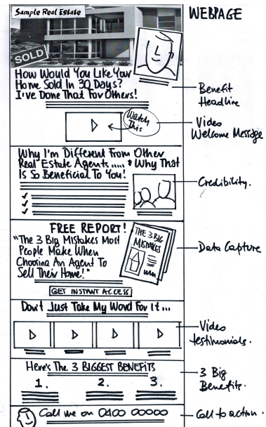
Suggested Landing Page:

- Letterbox brochures:
Of course, it comes as no surprise that I suggest you target the homes in your “area” with either door hangers or letterbox brochures.

Nothing new about this I realise – but I’m sure you agree that for decades, real estate agents have been wasting their time and money on silly letterbox flyers that simply say “we have buyers in your area!”

I have included in this report a number of examples of possible letterbox brochures, these samples or mock-ups having been put together for other real estate agent clients.

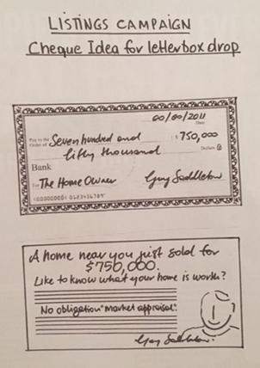
It may be that you invite the home owner to get a free appraisal on the value of their home and be in the draw for a $100,000 prize.

(This would be one of the “insured prize promotion” concepts – which you have received a link for the Blueprint download).

You need to determine whether the letterbox brochure goes to 5,000 or 10,000 homes etc. throughout your area.

And of course, it goes without saying that you can’t be a “one-drop-wonder” – such “area” marketing needs to be a regular occurrence for obvious reasons.

You’ll see from the samples herein, a range of ideas:
- A $100,000 prize giveaway incentive for appraisals (insurance premium about $2,000)
- An invitation to a “Home Improvement Evening”
- A “cheque” representing a recent sale price in that area (the idea being to “shock” home owners into being intrigued with what their own home might be worth!)
- A cheque that represents the sale price of a home in that particular district – with details on the back of that DL size cheque about your agency and the fact that you are experts at selling homes etc.

These letterbox brochure concepts can easily be turned into “door hanger campaigns” – it’s just a matter of punching a hole in the top of the flyer and arranging for distributors to actually hang on the front door knob.
Major letterbox companies such as Salmat and PMP Distribution probably can’t do the “door hanger thing” but I’m guessing you would be able to arrange senior school children to perhaps do this for you?
Suggested Brochures:

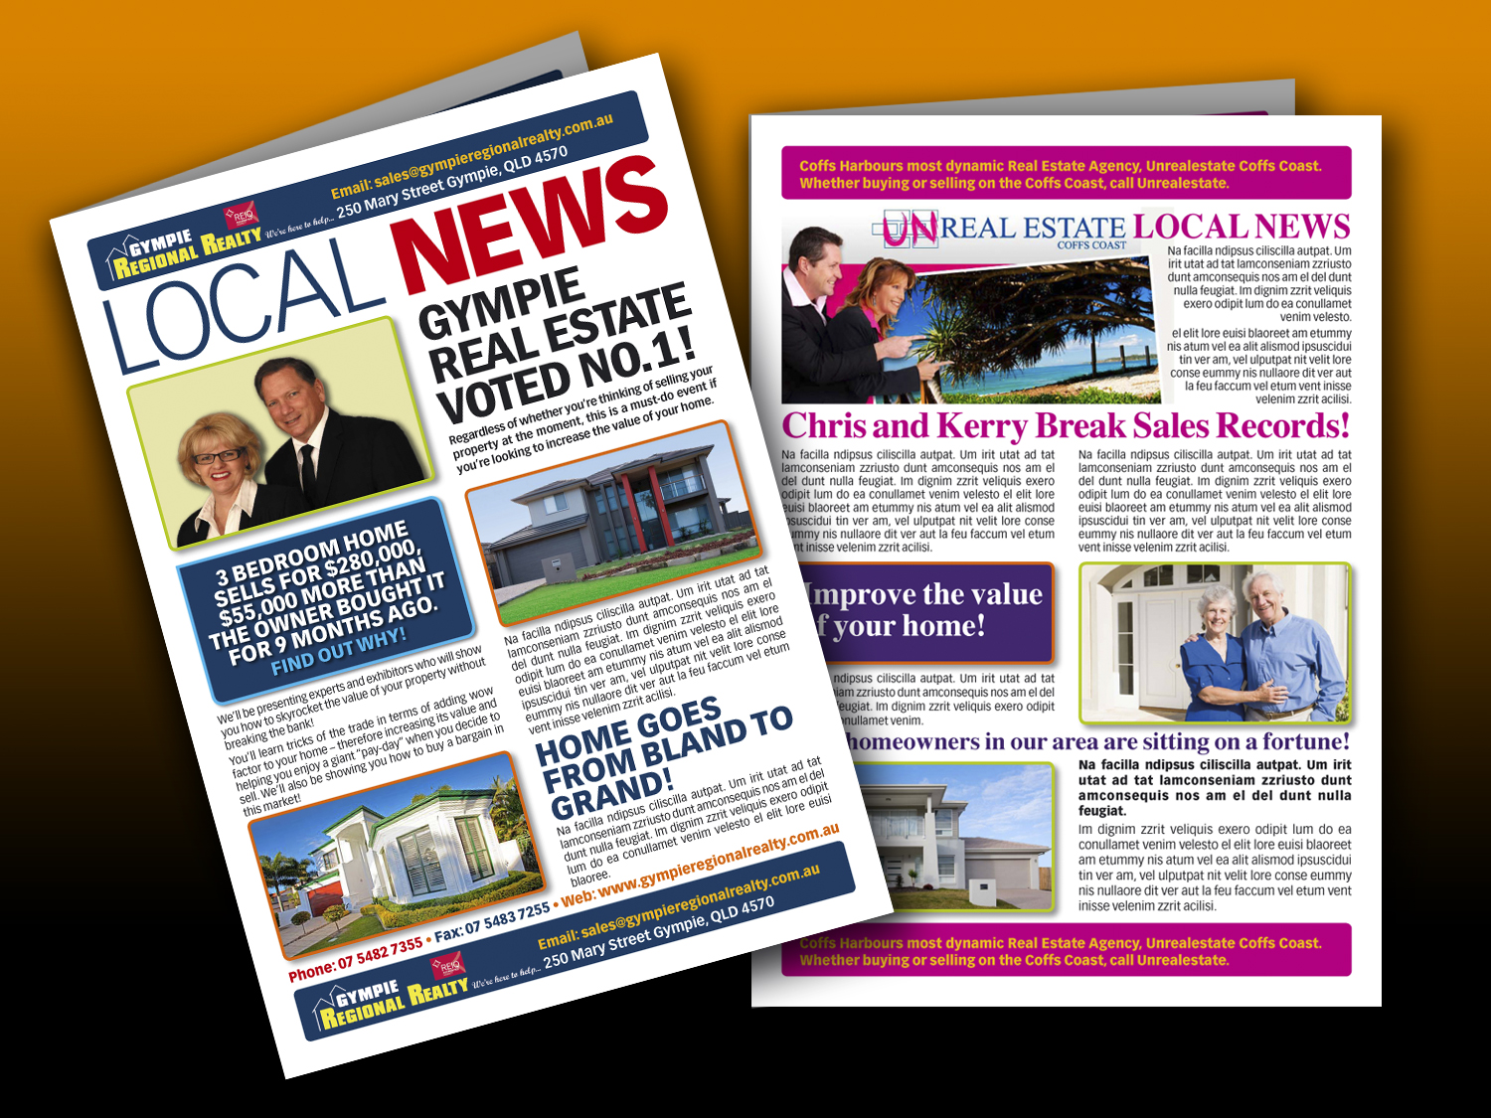
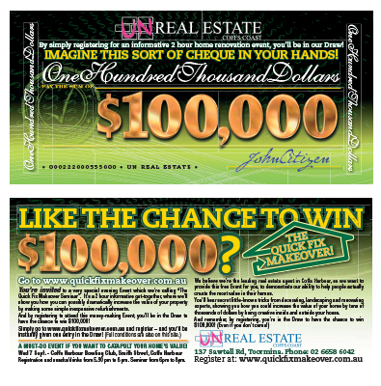
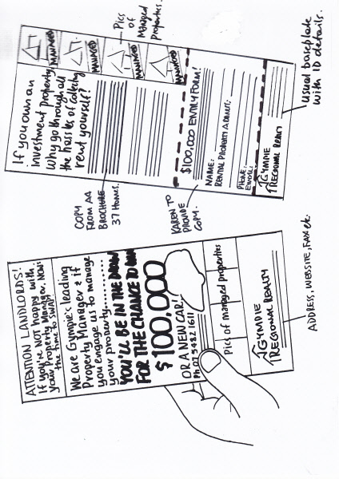
Brochure Samples:

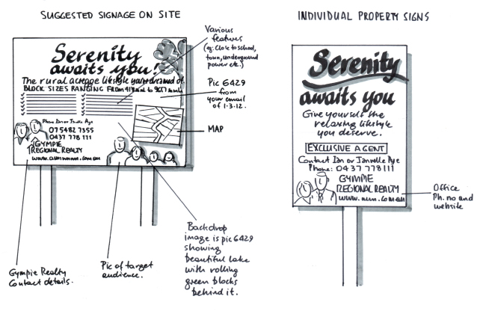
Signage Samples:
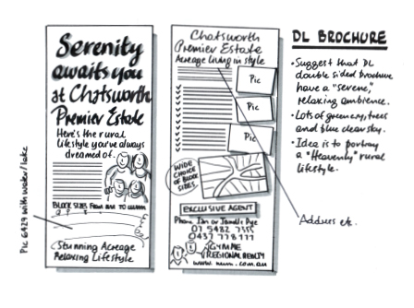
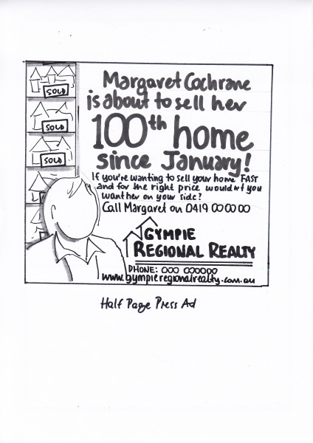
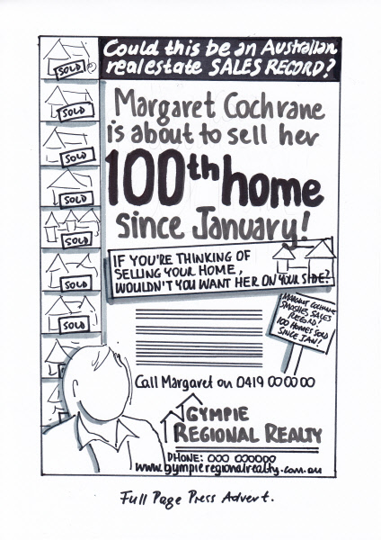
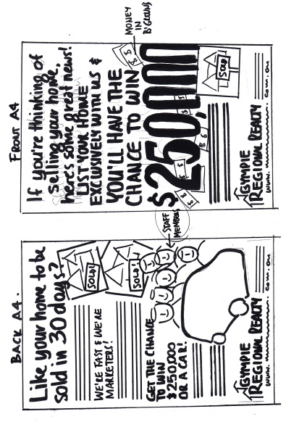
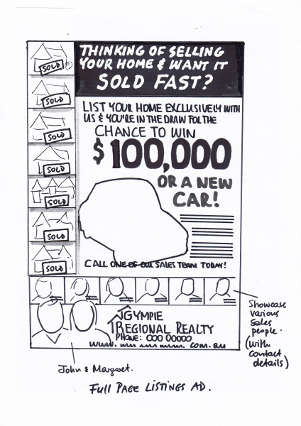

- Home Improvement Evening:
The idea is to invite home owners to the local RSL club or Function room with the lure of them gaining valuable information about how they can increase the value of their home – by making some subtle design and landscaping changes.

The idea is to invite the homeowner to attend a “Home Improvement Evening” event which you would sponsor and host.

You would be completely upfront in the letterbox invitation, explaining that you believe you are the expert when it comes to real estate in your area and you are simply sponsoring this free event in order to “build your brand”.

(When in reality, you are trying to attract home owners to an event where you would hi-jack the audience and give them an incentive to give them a free appraisal).

You would simply need to arrange a couple of guest speakers, perhaps one might be an interior designer and the other a landscaper?

Hopefully they would be keen to be involved, as they are going to be able to present their businesses and skills in front of a captured audience.

Suggest you put on a light buffet style dinner or canapes (with a few drinks) and invite people to enjoy a 90 minute evening from 6pm.

Your guest presenters would provide ideas on how people could dramatically increase the value of their home by doing some small, inexpensive renovations.

And after everyone has enjoyed a few drinks and your guest presenters have finished, you then “hi-jack” the audience and give them an incentive to get a free appraisal of their home.

The rational of your offer is that they should get a free valuation before they do any small renovations – so that they can compare this valuation with one a little later down the track – and therefore crystallise the value of their inexpensive renovations.

You’ll see from the sample brochure herein, that you may care to make the evening event even more attractive with a lure of a $100,000 prize giveaway (insured prize).

And if on the evening the homeowner books an appraisal, they get a disproportionate amount of extra entries.

If you would like to read more about how to present such an event, you may care to go to my Wow Manifesto download and refer to chapter 6 on page 112, where I talk about how to “do events”. Here’s the link: chapter 6 on page 112

- Outbound Telemarketing:
If you wanted to test an outbound telemarketing campaign to areas within your area, you can call upon the services of www.dsadata.com.au – a company which can provide you with the telephone numbers of home owners in specific suburbs.

For example, if you drop 10,000 brochures inviting home owners to accept a “complimentary appraisal”, you may care to test 500 or 1,000 telephone calls as a follow up?

DSA Data can provide you with phone numbers of the homes you have letterbox distributed to – and the last time I gained a quote for 5,000 phone numbers, they were around $0.27cents each.

Contact details are:
www.dsadata.com.au
Ph: 02 8908 7788
Contact: David Webb
Em: dwebb@dsadata.com.au

- “Do you know what you’re worth” – letterbox campaign:
I’ve kept this separate from my other letterbox campaign ideas, because it’s an “evergreen concept” that you could use at any time.

As I’m sure you know, most Australian’s have the bulk of their net worth tied up in their family home.

But the bizarre thing is that most Australian’s don’t know what their home is worth – and therefore don’t have any real grasp on what their total worth actually is!

So I recommend that you consider putting together a letterbox campaign that specifically highlights to people that they are possibly “sitting on a considerable amount of money and don’t know it!”

The invitation would be to find out the true value of their home so that they know exactly how much they are worth.

My belief is that this could be a “wake up call” for many people – and hopefully when you have provided them with an attractive appraisal, there will be a certain quantity who may think about “cashing in”.

Essentially, this is a pretty attractive invitation to home owners within your area “to find out their true wealth”.

I suspect that this would be a pretty “tempting” invitation for most people.

- Wow Factor Bonus for Listings:
You’ll see within this report, samples of some promotions I assisted Gympie Realty with, one of which is a big cash prize incentive.

No need to really go into fine detail here as the sample marketing collateral herein pretty much describes everything.

Home owners receive the incentive of being in the Cash Prize Sweepstakes Draw as a bonus for exclusively listing with Gympie Realty.

You’ll see from the artwork herein that both buyers and sellers have a chance of winning the prize, with a guaranteed giveaway of a motor vehicle.

The cash prize is insured – you can get a $50,000 prize for around about $1,100 premium.

The insurance company contact details (AIS Insurance Brokers) is in the Supplier List with this report.

- Online Marketing:
I have not devoted any space in this report to providing you with marketing ideas regarding “selling”- as I think we both agree that www.realestate.com.au is essentially the major marketing tool for any sale these days.

However, in terms of gaining listings, any of the before mentioned offline tactics could be translated to a PPC Facebook campaign, targeting the specific geographic region of your area.

It’s just a matter of turning the “offline creative” into an “online Facebook ad”

- General Creative Thoughts:
I assume that you have enjoyed on the odd occasion, the thrill of selling a property within 10 days, 20 days or 30 days of its listing?

I realise doesn’t happen all the time, but if you have enjoyed such a stunning result, I recommend that you exploit this in your “headlines”.

I had an agent in South Australia as a client a couple of years back, his name was Mark Battersby.

He took my advice and created an advertising digital skin for his car which said something like “Would you like to sell your home in 30 days? I’ve done that!”

He had actually sold a couple of homes within that period of time and was therefore taking advantage of that fact.

He said he had random calls from home owners who had seen his signwritten vehicle asking “Are you the guy who sells homes within 30 days?”.

Obviously he couldn’t guarantee that result for everyone, but the fact that he boasted about his previous achievements meant that he picked up listings that he ordinarily wouldn’t have scored.

May I also suggest that if you have won any industry awards or broken any records, that this sort of information should be across all of your marketing communications, including of course your website.

- Online Social Media:
It goes without saying that “social media” exposure is important in today’s world.
So I suggest that you ensure that you are a regular contributor to Facebook and any other social media platforms you believe are appropriate to your skill-set.

But of course, Facebook is the major “influencer” in the online world, so I recommend that you regularly project your “brand persona” and achievements by regular posting.

Joe,
Hopefully this Marketing Action Plan will give you lots of “food for thought” in terms of marketing your real estate business and your own personal brand.
Please keep in mind that I have still had only a relatively short exposure to your business and therefore throughout your membership of my program, there’s likely to be some fine-tuning of the recommendations herein.
Given the importance of your “personal brand persona” in the game that you’re in, I would like to reinforce my recommendation that you feature heavily in video testimonials on your website and online in general.
In this day and age, “video is king” – and all of us need to recognise how powerful it can be in persuading our target audience to use our services.
And aside from video on your website, I suggest you also use this powerful marketing tool on social media.
Given that most people have not sold many family homes, it’s vital that you project a professional and experienced “brand” in the market place, as understandably most prospective vendors will be looking for a shoulder to lean on.
It’s very important that you present yourself as “the expert” and highlight any unique bonuses and advantages that you bring to the table.
Welcome to my program and I look forward to helping your business throughout your membership.
Kind Regards
JD
John Dwyer
Ph: 07 55 919 566
Fx: 07 55 919 555
Em: johndwyer@theinstitiuteofwow.com

PO Box 1227
Oxenford QLD 1227

